Topic: Computer Mouse and Laptop Touchpad
When I am done this lesson, I will know:
- The basic parts of a mouse
- The difference between a mouse and a touchpad
- How to use a mouse

Pre and Post Self-Assessment
 | Pre | Pre | Post | Post
 | Yes, I know this | No, I want to learn this | Yes, I know this | I still need more practice to learn this
I know the parts of the mouse and what they do
I know what the difference is between a mouse and a touchpad
I know how to use a mouse


New Words and Terms
cursor
button
scroll wheel
scroll
click
drag
Computer Mouse
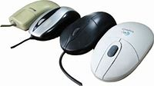
The computer mouse is a pointing device that responds to gentle hand movements. It is called a computer mouse because of the wire that connects the mouse to the computer. The people who designed it thought that it looked like the tail on a mouse. Computer mice come in many different colours and sizes. Some need to be connected to the computer with a cable. Today, many computer mice use wireless technology and have no wire.
The mouse is used to control or move the cursor on a computer screen. The cursor indicates the current input position on a computer display screen. The cursor is also a visible and moving pointer that the user controls with a mouse or touchpad.
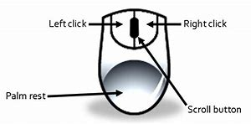
Parts of the Mouse
Generally, there are 4 main parts of a computer mouse:
- Left click button
- Scroll wheel or button
- Right click button
Palm rest
Left Button: This is the button you click when you want to select or open an item.
Right Button: This is the button you click to display a list of things you can do with an item such as delete, cut, copy, or create a new folder.
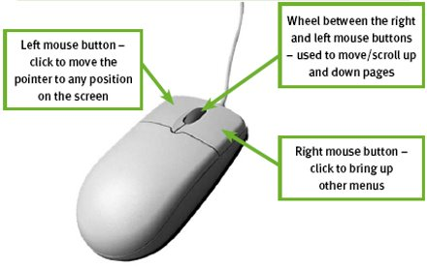
Scroll Wheel: This wheel can be used to quickly move up and down a webpage or through a large document.
Using the Mouse – “Clicking”
Clicking is the term used to describe when you press down on one of the buttons.
A “click” is when you press down once on the left mouse button.
A “double click” is when you press down twice on the left mouse button.
A “right click” is when you press down once on the right mouse button.
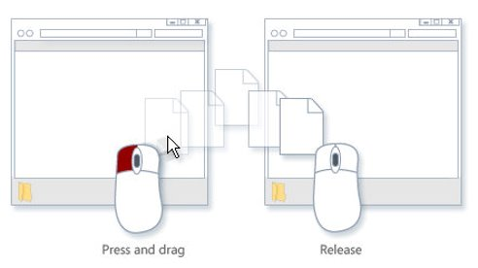
“Click and Drag” is done by holding down the left mouse button while dragging (moving) over a selected (highlighted) object or text.
Moving the Mouse Around the Screen
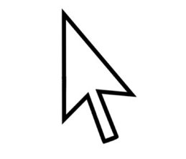 | You use gentle movements with your mouse to move the cursor (white arrow) on screen where you want it to be. While you are moving the mouse around the screen, the white arrow will show.
 | When your cursor turns into a capital “I” that means if you click on that spot you will be able to type something.
 | When your cursor turns into a white hand that means if you click on that spot you will be connected to another webpage or a different place in a document.
Laptop Touchpad
You can use a mouse with a laptop. Laptops also have a “built-in” mouse called a touchpad. This is sometimes called a trackpad. A touchpad works the same way a mouse does, but you can’t see the buttons and wheel.
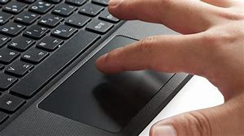
The surface tracks the motion and pressure from your finger and relates it to the screen.
- If you move your finger across the touchpad, the cursor will move across the screen.
- Tapping the touchpad works the same as left clicking on a mouse.
There is a “hotspot” near the middle of the touchpad that acts the same as a scroll wheel on the mouse.
 | Watch this short video to learn how to use a mouse.  Source: Youth Policy Institute Department of Educational Technology | https://www.youtube.com/watch?v=_3s_OYgtl8g

Check Your Knowledge
- What does clicking the left button do?
- What does clicking the right button do?
- How can you move though documents quickly?

Try this/Practice
Use this interactive tutorial to practice using a mouse.  Source: GCFGlobal.org | https://edu.gcfglobal.org/en/mousetutorial/

Optional: I Want to Learn More
Practice using the mouse with “Mousercise!”: http://www.pbclibrary.org/mousing/mousercise.htm
Practice using the mouse at “Mouseprogram.com”: http://www.mouseprogram.com/practice.html

Ontario Adult Literacy Curriculum Framework Connection
Competency | Task Group(s)
Find and Use Information | Read Continuous Text (L2 – paragraphs, long sentences)  Interpret Documents (L2 – variety of information, icons, text)  Extract Information from Films, Broadcasts and Presentations
Communicate Ideas and Information | Complete and Create Documents (L2- pre and post assessment)

